How to Use Email on Office365 Web

STANDARD OPERATING PROCEDURE

# Index

1. Introduction
2. Step by step Use of Email on office 365

# Introduction

Outlook on the web makes it simple to keep your email, calendar, and contacts right at your fingertips. Here are a few of the great features to use:

* Send messages and share files to collaborate with others.
* Use Suggested replies or the Like button to save time.
* Focused inbox keeps what matters most front and centre.
* Pick a time in your calendar to use quick compose or select More options to add more details to your event.
* Use Smart time suggestions to find a meeting time that works for everyone.
* Make your meetings a Teams meeting or quickly find a place to meet with Suggested locations.
* Connect your Microsoft 365 account to LinkedIn to send messages and share files with your connections.
* Search lets you quickly find emails, events, and contacts.

# Step by step Use of Email on office 365

* Go to any browser on your system – Link name **office.com** or [**https://www.office.com/**](https://www.office.com/)

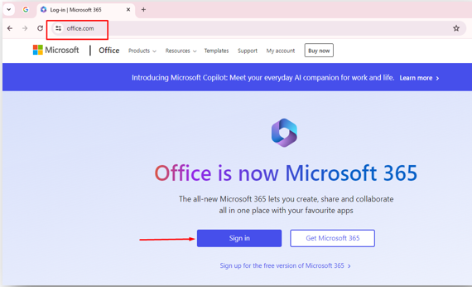

* Click on **Sign in** button

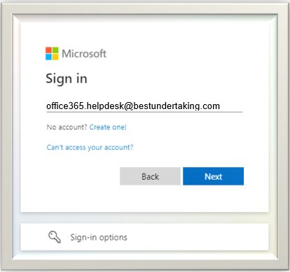

* Type **your email** and click on **Next**

* Update password.
* 1st Line Current password – Temporary Password
* 2nd Line New Password- Create your new own password.
* 3rd Line Confirm Password – Your New password.
* **MFA Setup Prompt: Multi Factor Authenticator**
  + After logging in, you will be prompted to set up additional security verification.
  + Click on **Next** to begin the setup process.

* **Mobile App Setup**
* For Mobile Setup
  + 1. Download the **Microsoft Authenticator** app from the App Store (iOS) or Google Play Store (Android).
    2. Open the app, tap **Add Account**, and select **Work or school account**.
    3. Use the app to scan the QR code displayed on the Office 365 setup page.
    4. After scanning the QR code, the app will display a two-digit code. Enter this code on the Office 365 setup page.

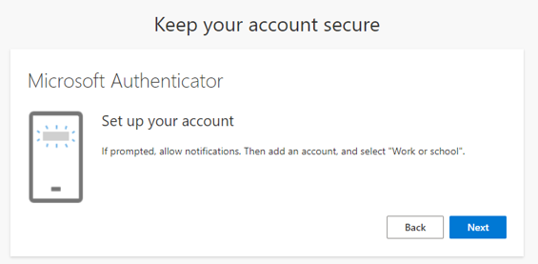

**OR**

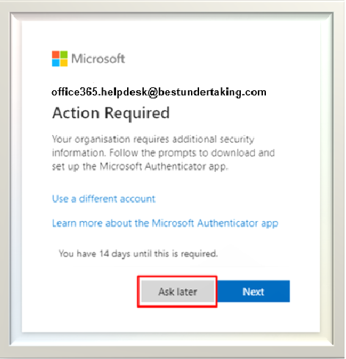

* You Can configure Microsoft Authenticator app on Mobile letter also.
* So, click on Ask later button.

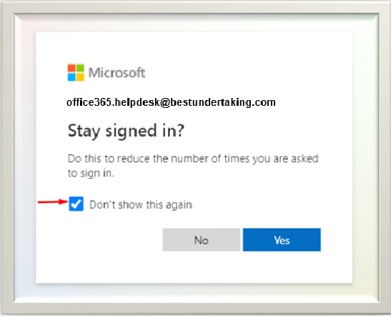

* Select Don’t show this again and select No or Yes as per your convenience or as per company policy if its already defined.  
  **If click on No**- Every time password needs to type  
  **If click on Yes** – It will save in your system and no need to put password A screenshot of a computer

  Description automatically generated

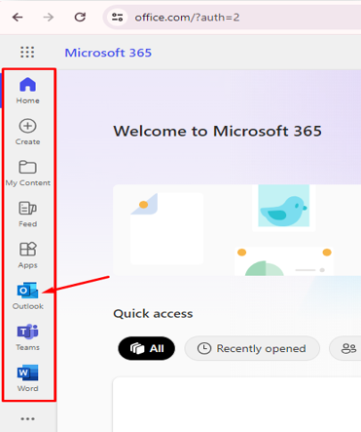

* After Startup configuration above page will get **Left Side panel** click on **Outlook Tab** to check emails.
* You can now access your emails, compose new messages, and manage your mailbox.

.